

**CompliSign**

for

Operator Admin

Table of Contents

Operator Admin Functions 4

Logging in 4

The Operator Admin Dashboard 5

Orders 5

Viewing and editing an order 6

Order Details 7

Making a new order 7

Adding order information 8

Schedule exam 9

Assign to physician 9

Select Status 10

Confirm Order 11

Patients 12

Adding or editing patients 12

Patient data at a glance 13

Technicians 13

Adding or editing a technician 14

Technician data at a glance 14

Adding a technician 14

Physicians 15

Viewing, editing or adding a physician 15

Physician data at a glance 16

Adding a physician 17

Facilities 18

Viewing, editing or adding facilities 19

Facility data at a glance 19

Adding a facility 20

Schedule 20

Viewing schedule 21

Schedule details 21

Letters 22

Viewing letters 22

Generating letters from uploads 23

Matching physician 24

Viewing Letters 25

Reports 26

Sample custom report 26

Activity 27

Viewing activity log 27

Signing out 28

# Operator Admin Functions

CompliSign users with an Operator Admin login have the right to:

* View, edit and add Patients, Technicians, Physicians and Facilities
* View and edit existing orders
* Make new orders and schedule technicians
* View and edit schedule
* View physician letters
* Create and view custom Reports
* View activity

# Logging in

* Navigate to your company’s CompliSign URL
* Enter the username that you received at startup
* Enter the password that you received at startup

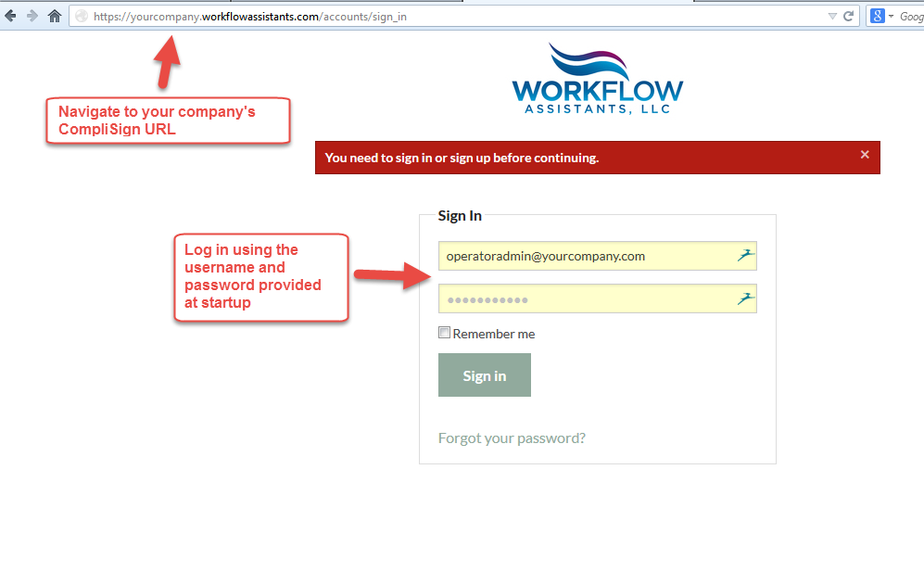

# The Operator Admin Dashboard

From this Dashboard, the Operator Admin user can:

* View, edit and add Patients, Technicians, Physicians and Facilities
* View and edit existing orders
* Make new orders and schedule technicians
* View and edit schedule
* View physician letters
* Create and view custom Reports
* View activity

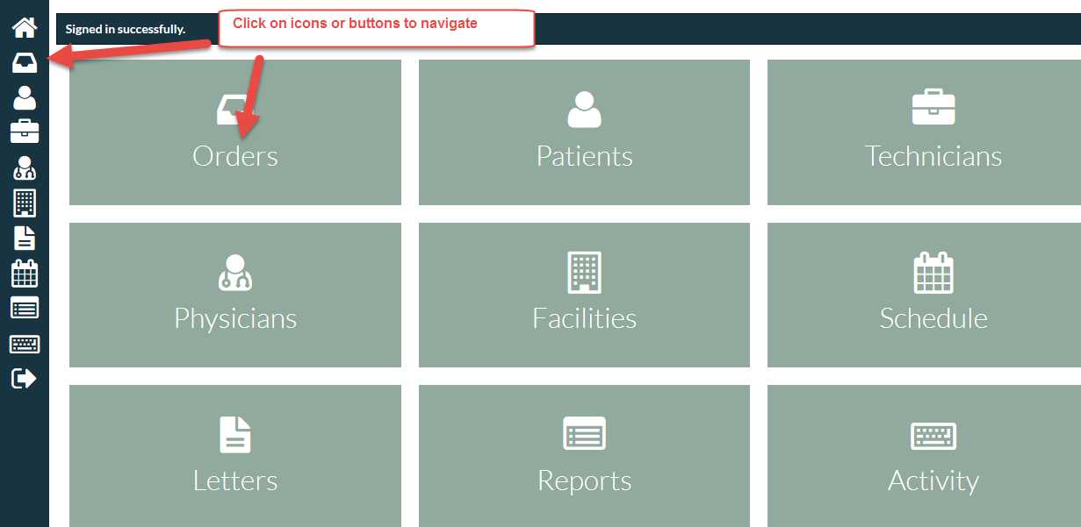

# Orders

On the Orders screen, Operator Admin users can:

* View existing orders
* Check the status of orders
* Edit as necessary
* Make new orders

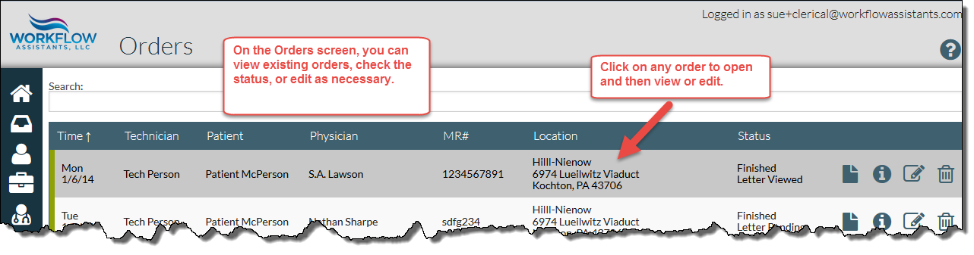

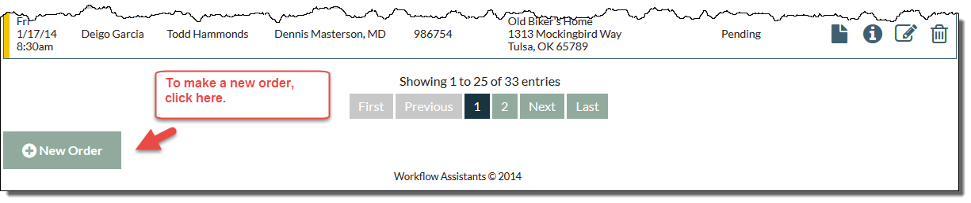

# Viewing and editing an order

From this screen, the Operator Admin user can:

* Edit order
* Attach supporting documentation
* Delete the order

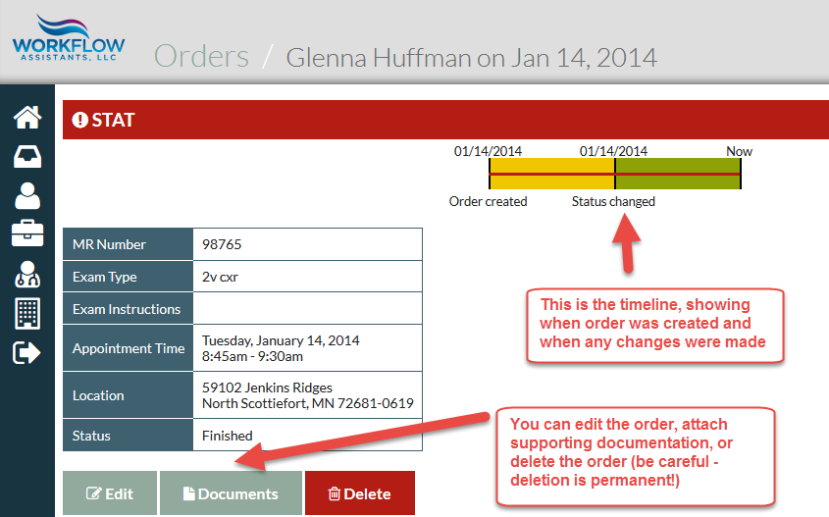

# Order Details

From this screen, the Operator Admin user can see all pertinent order details at a glance.

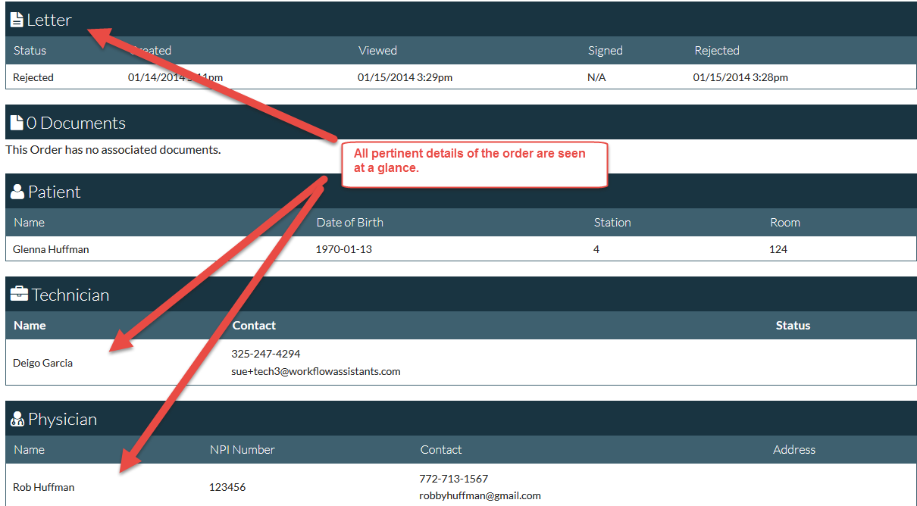

# Making a new order

From the dashboard, click on the Orders button or icon

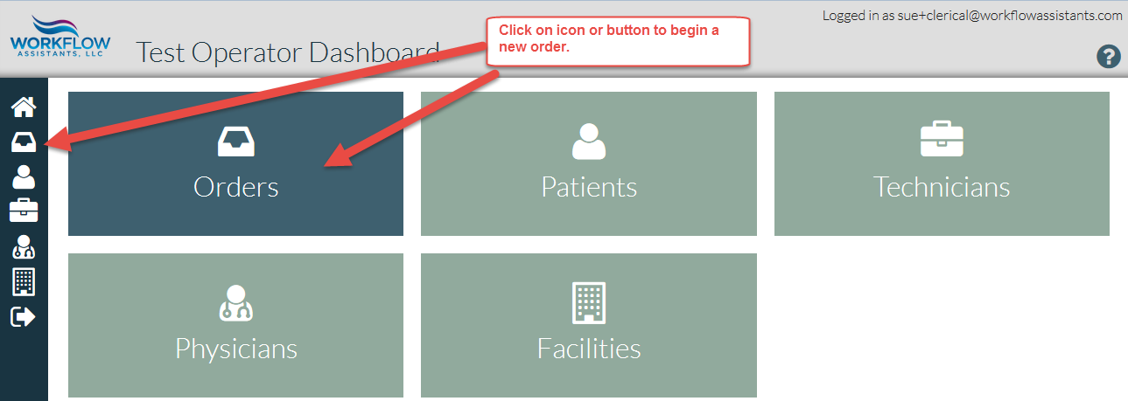

At the bottom of the Orders screen, click on New Order.

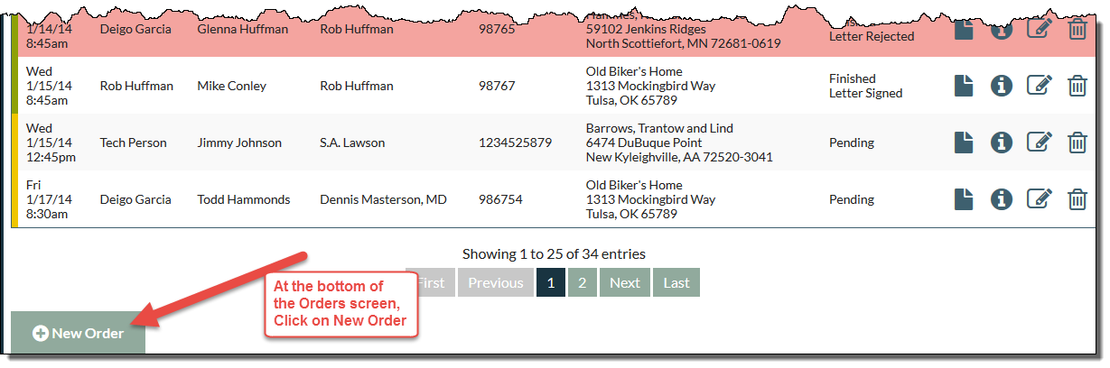

# Adding order information

On the Create Order screen, enter patient information on the Patient tab. The justification for a portable exam field is a drop-down menu.

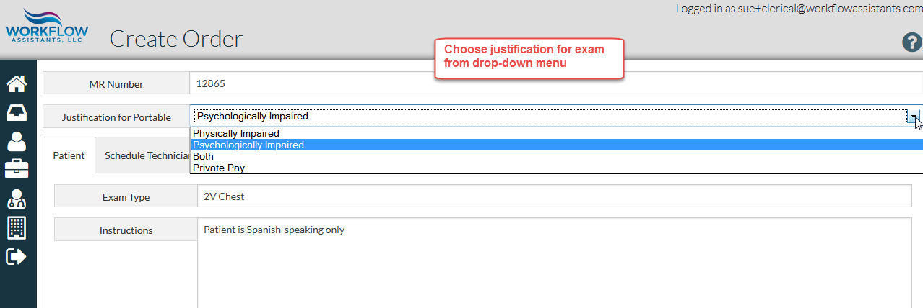

Select existing patient from drop-down menu, or add information for a new patient.

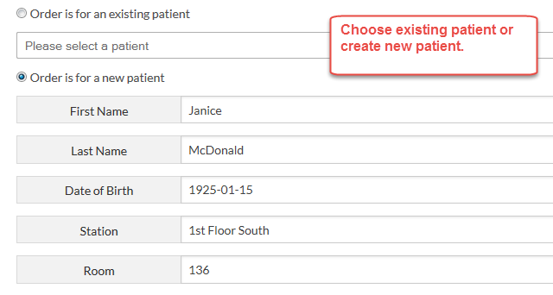

Choose existing facility from drop-down menu or add facility.

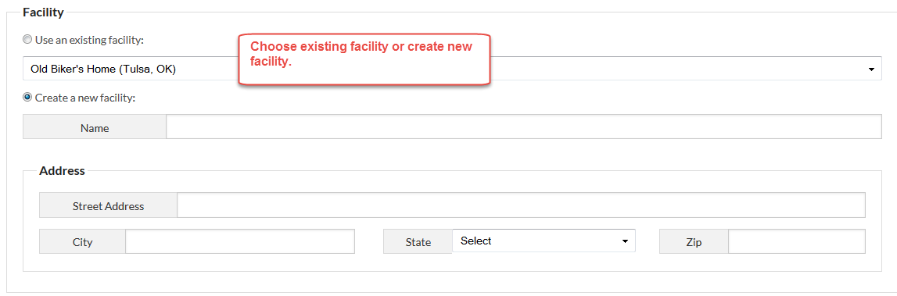

# Schedule exam

On the schedule technician tab, select the date on the calendar, select start time and end time from drop-down menus if applicable, and select technician from list.

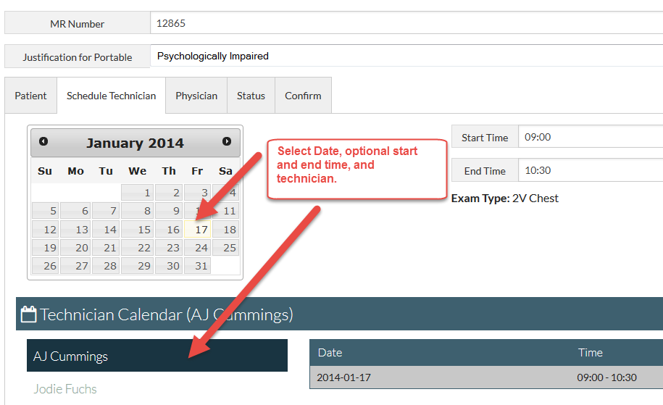

# Assign to physician

On Physician tab, select physician from drop-down menu or enter information for new physician.

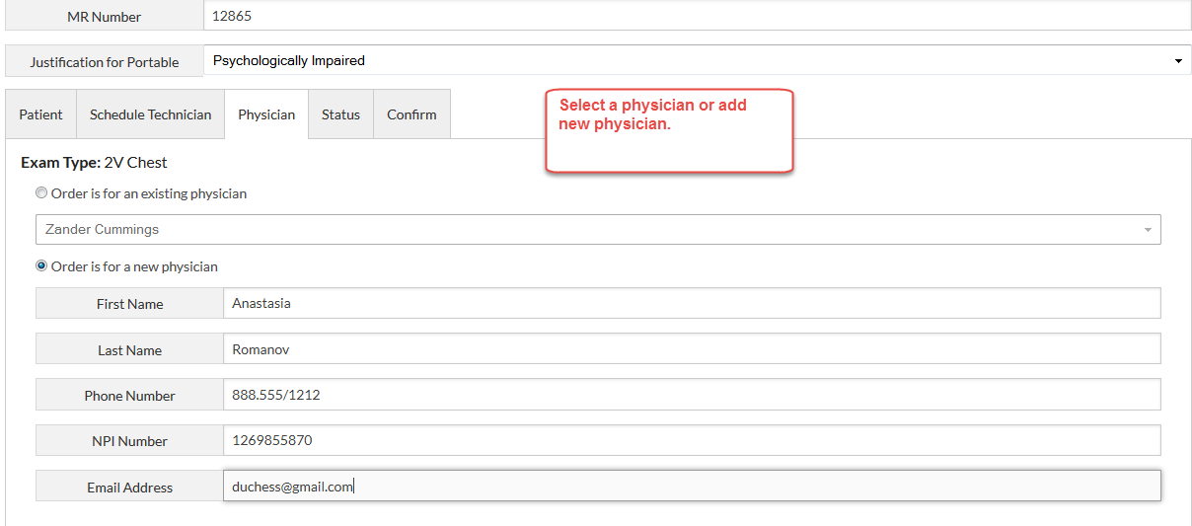

# Select Status

Status for a new order is Pending by default. Click on STAT if applicable. Click on Film Print and Delivery if applicable.

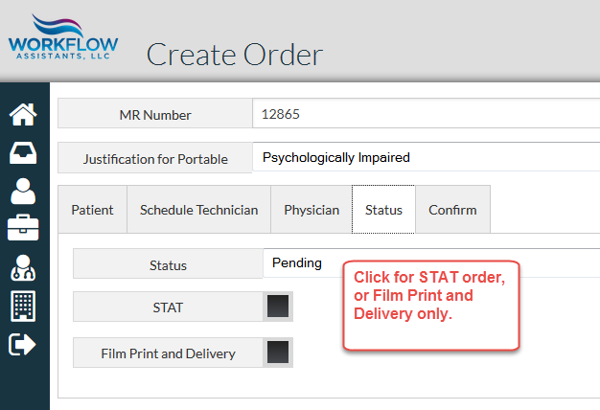

# Confirm Order

On Confirm tab, the Operator Admin user can:

* Review order details
* Confirm to schedule order
* Confirm and add documents to append supplemental documentation to order
* Confirm and Finish to sign off order and generate Letter to be signed

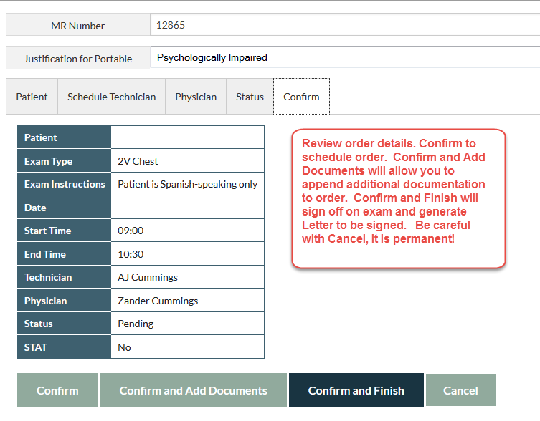

# Patients

On the Dashboard, click on Patients button or icon to view or edit patients.

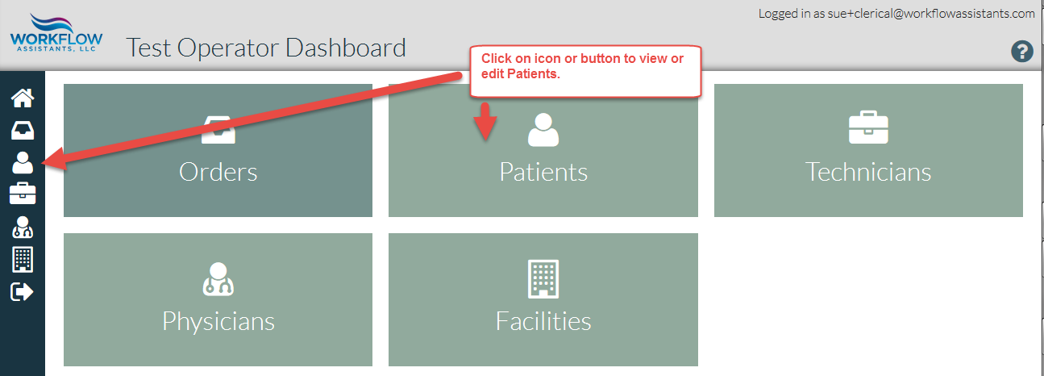

# Adding or editing patients

Click on patient name to view patient. Click on New Patient to add patient from this screen. Note – patient can also be added when creating new order.

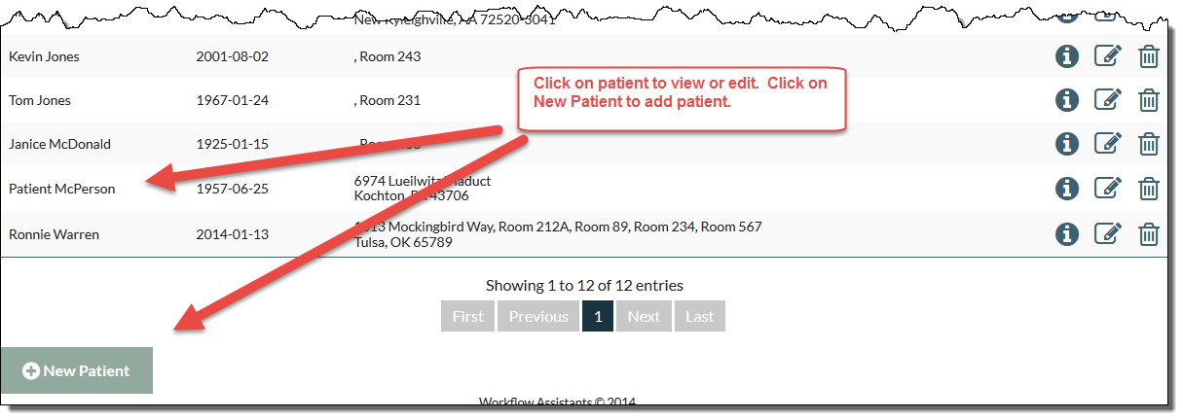

# Patient data at a glance

From this screen, the Operator Admin user can:

* View patient data
* Edit patient data

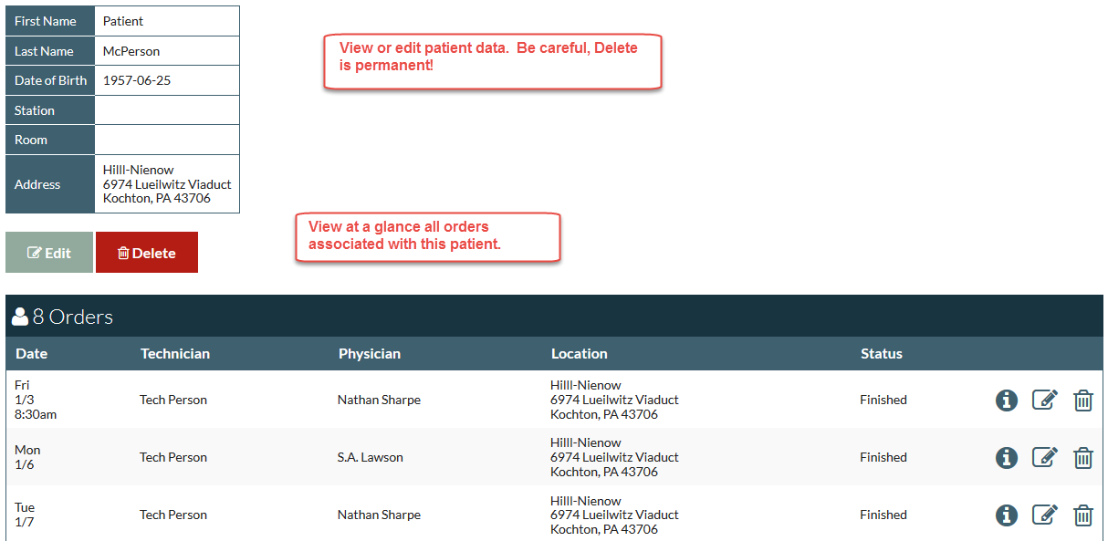

# Technicians

From the Dashboard, click on Technicians button or icon to view, edit or add technicians.

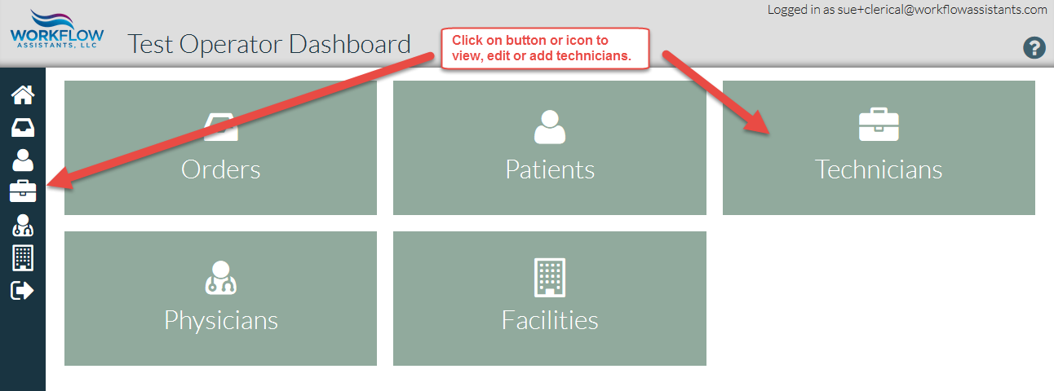

# Adding or editing a technician

Click on technician to view or edit details. Click on New Technician to add technician.

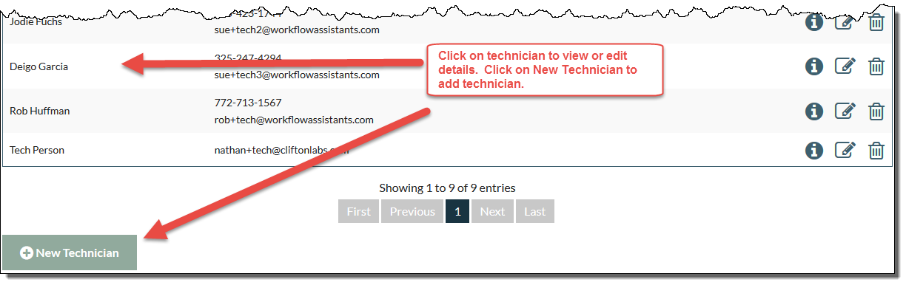

# Technician data at a glance

Click to edit technician data.

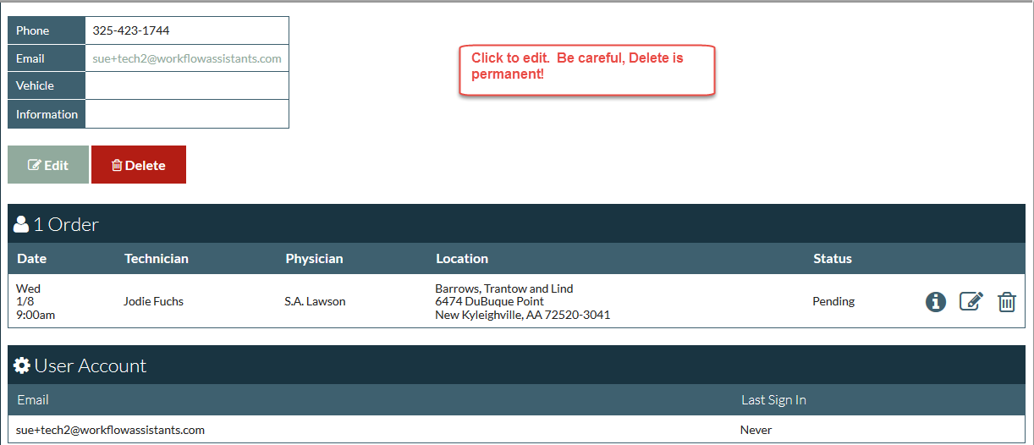

# Adding a technician

Add technician information to fields.

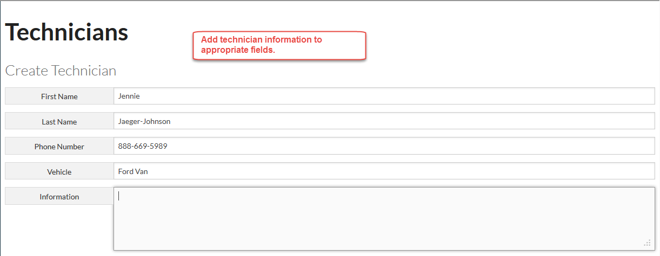

When finished, be sure to check box to create an account for the new technician.

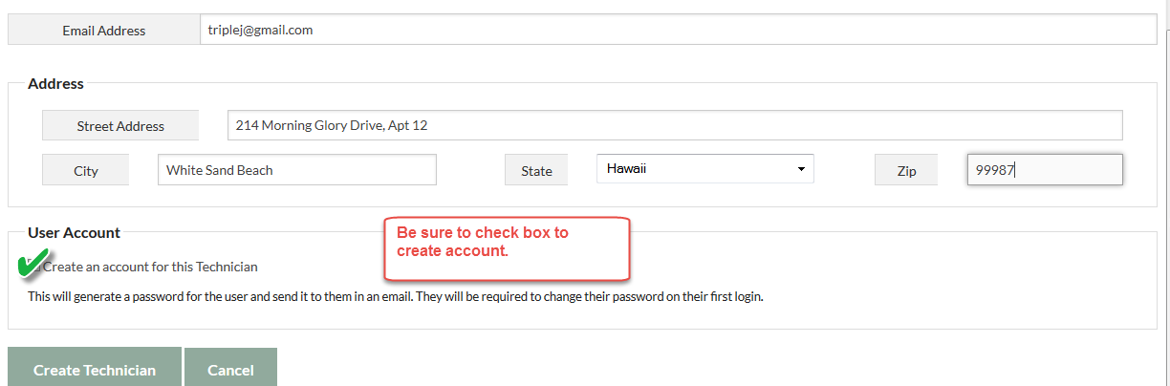

# Physicians

From the Dashboard, click on Physician button or icon to view, edit and add physicians.

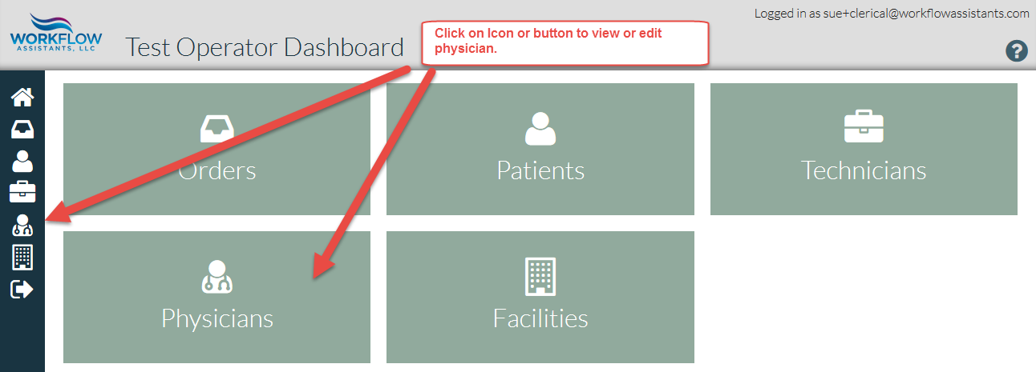

# Viewing, editing or adding a physician

Click on physician name to view or edit. Click on New Physician to add a physician.

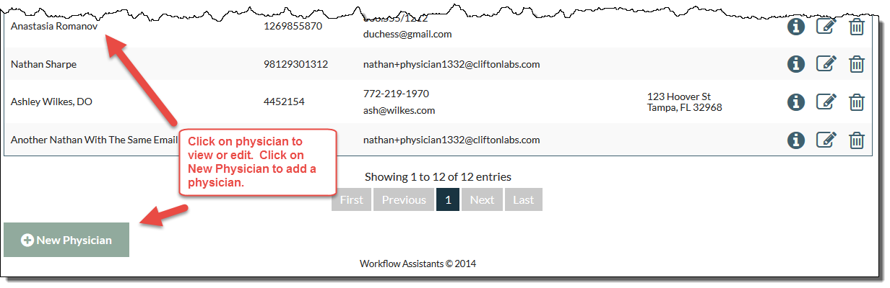

# Physician data at a glance

From this screen, the Operator Admin user can:

* Edit Physician information
* View all orders associated with this physician

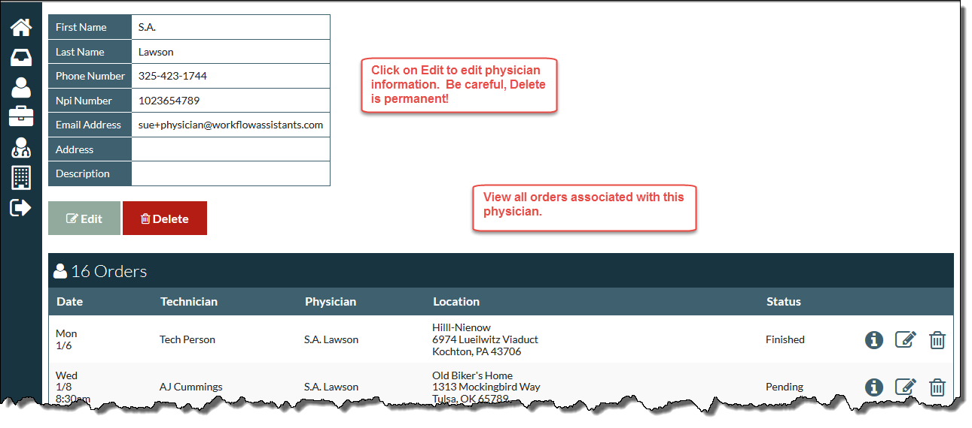

# Adding a physician

Enter physician information in fields. Click on Create Physician.

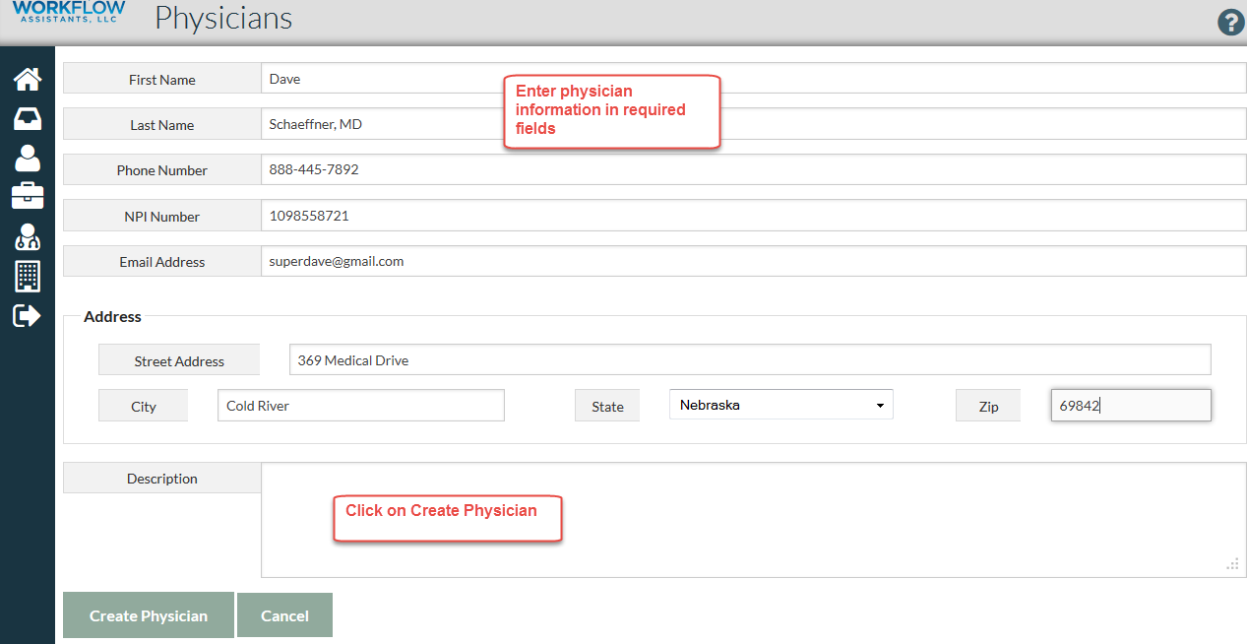

Creating Physician user account

Creating a physician has one additional step; a special user account with additional security features must be created. Click on Create a User Account for This Physician. 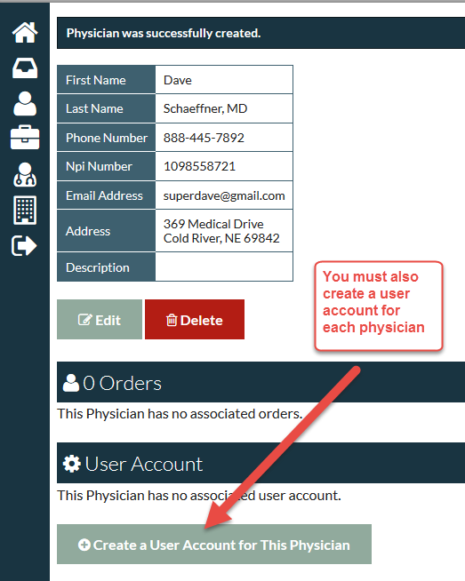

# Facilities

From the Dashboard, click on the Facilities button or icon to view, edit or add facilities.

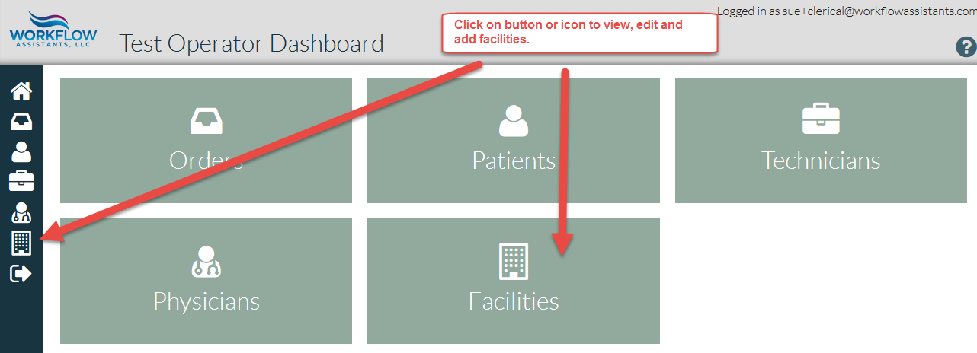

# Viewing, editing or adding facilities

Click on a facility to view or add. Click on New Facility to add a facility. Note that facilities may be added when creating a new order as well.

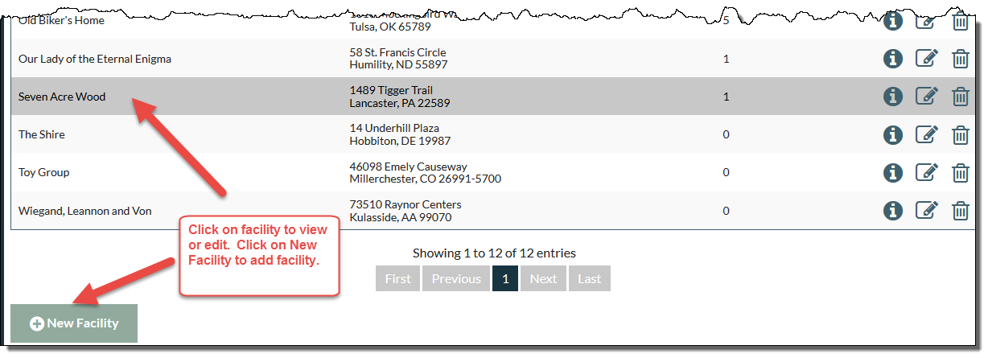

# Facility data at a glance

From this screen, the Operator Admin user can:

* Click on Edit to update facility information
* View all patients at this facility at a glance

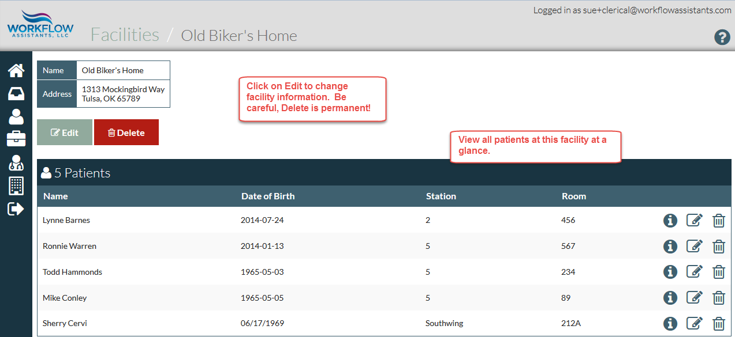

# Adding a facility

Add facility information in the fields. Click on Create Facility.

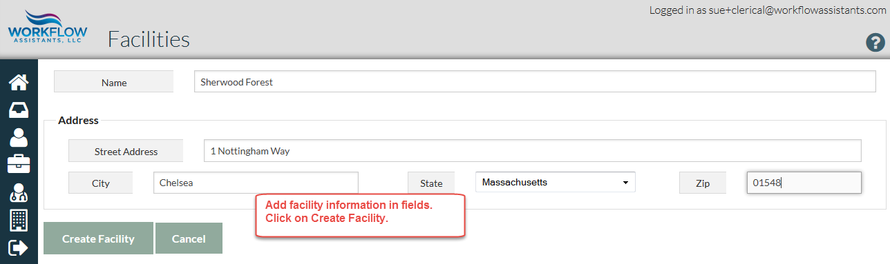

# Schedule

From this screen, the Operator Admin user can view and edit schedule for all technicians.

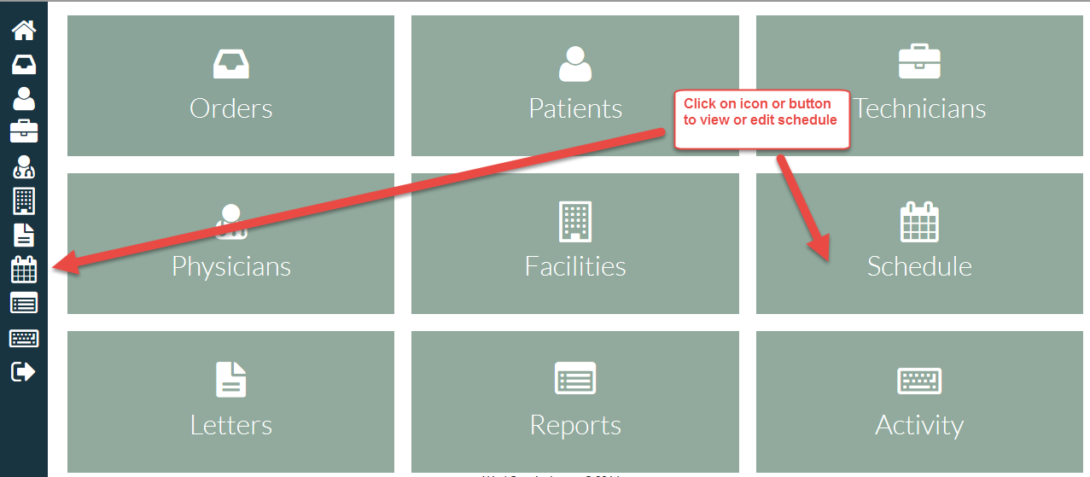

# Viewing schedule

View schedule by day, week or month at a glance. View entire schedule, or select one or more technicians by checking boxes.

# 

# Schedule details

Hover over a schedule entry to view details. Click on schedule entry to edit.

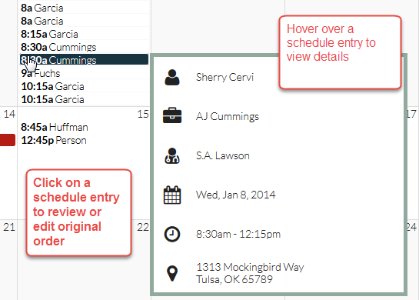

# Letters

View pending, signed or rejected physician letters.

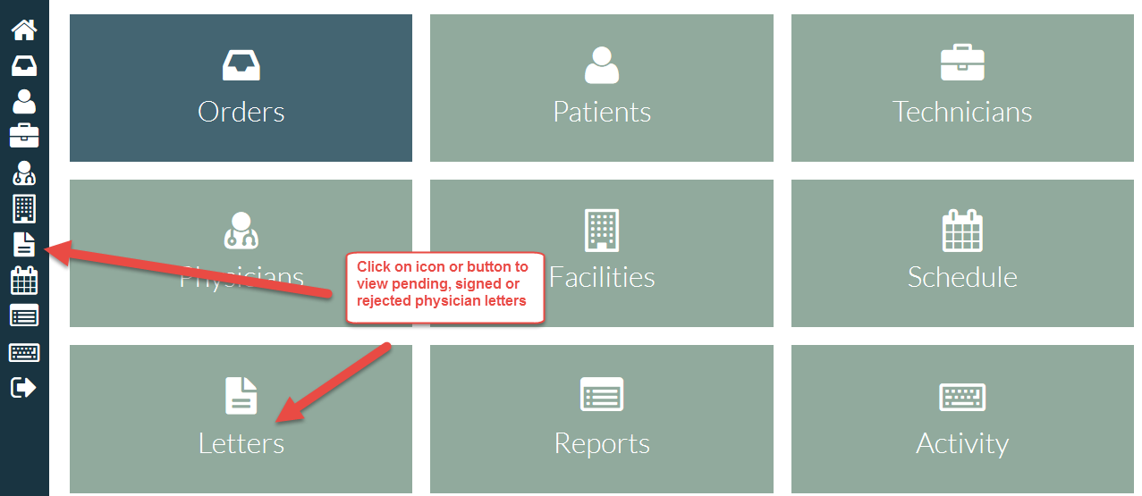

# Viewing letters

Letters are generated when an order is finished by a technician, or when metadata is uploaded and assigned to a physician.

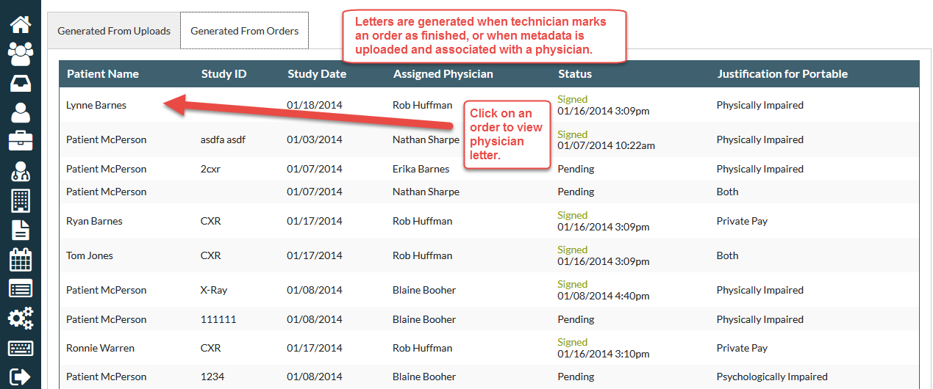

# Generating letters from uploads

Physician letters to be signed may be generated from uploaded metadata.

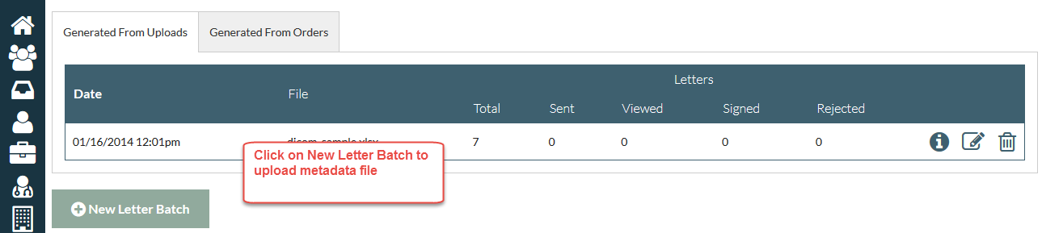

Browse for file and select. Name file and click Save.

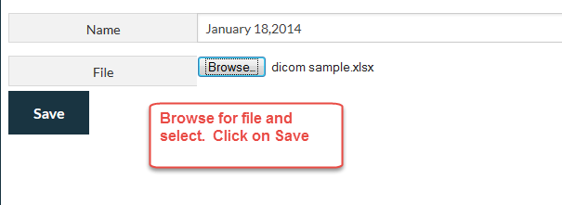

# Matching physician

Uploaded data may require manual physician match to generate correct letters. Choose physician from drop-down menu.

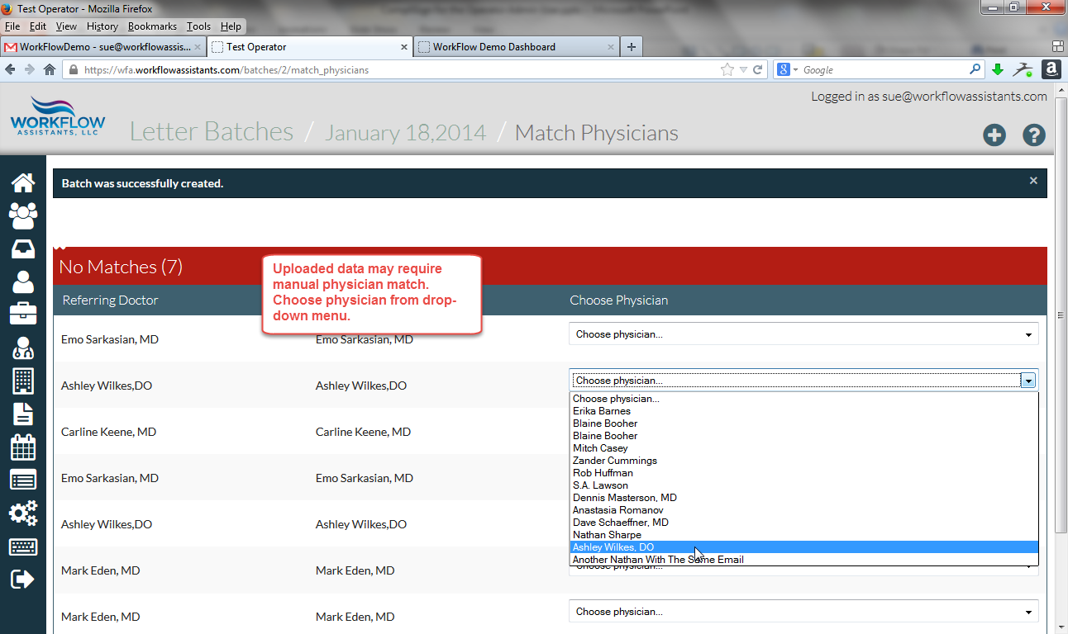

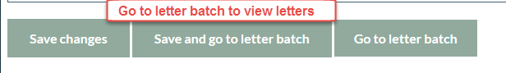

# Viewing Letters

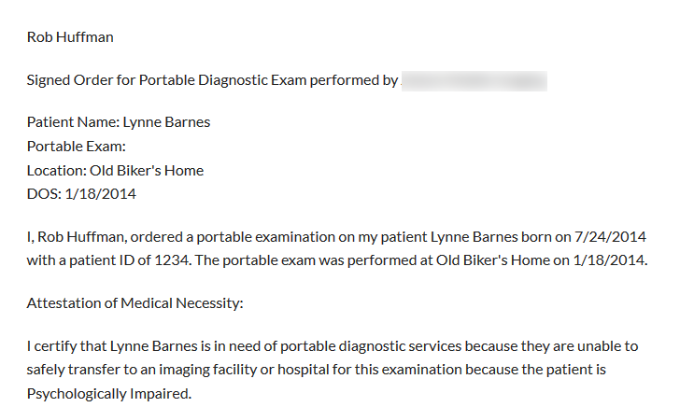

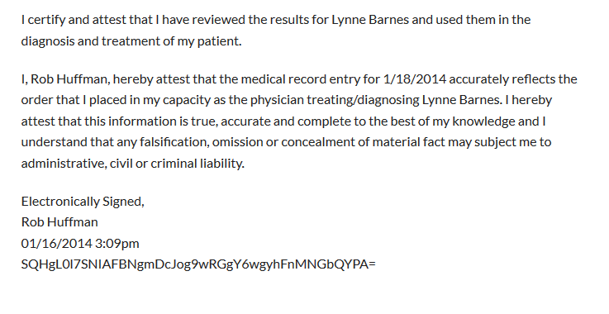

# Reports

Click on an icon or button to create and view custom reports

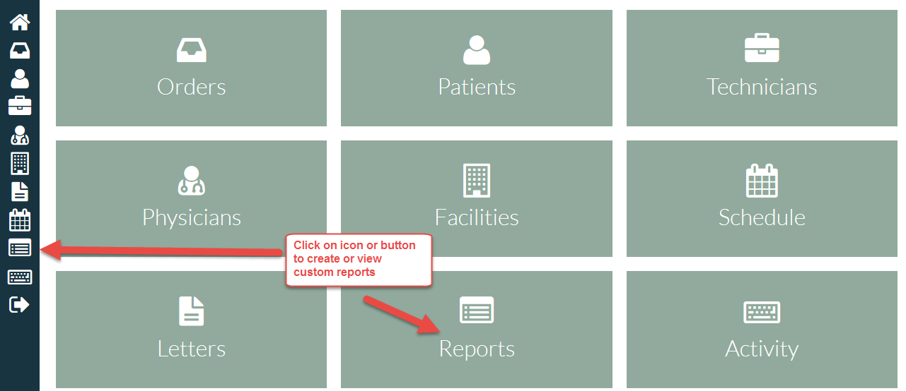

# Sample custom report

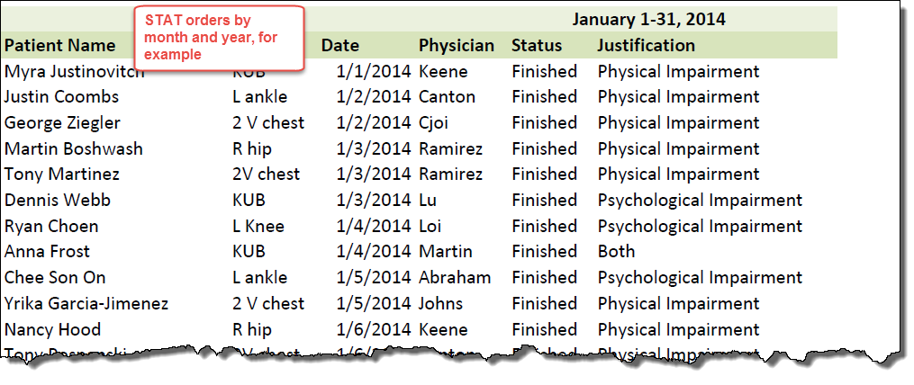

# Activity

Click on icon or button to view running activity log

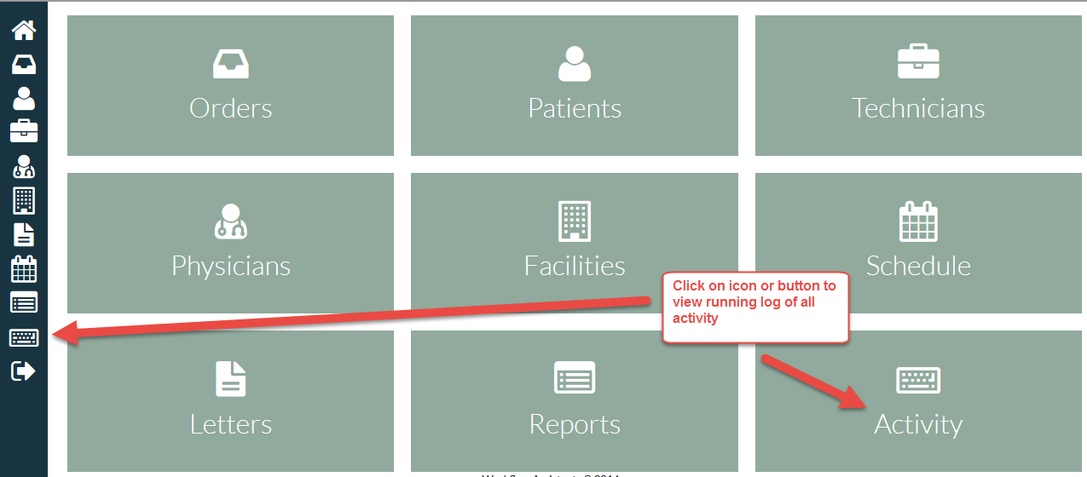

# Viewing activity log

This screen shows a running, chronologic log of all activity, including creation or deletion of orders, patients, technicians, physicians and facilities.

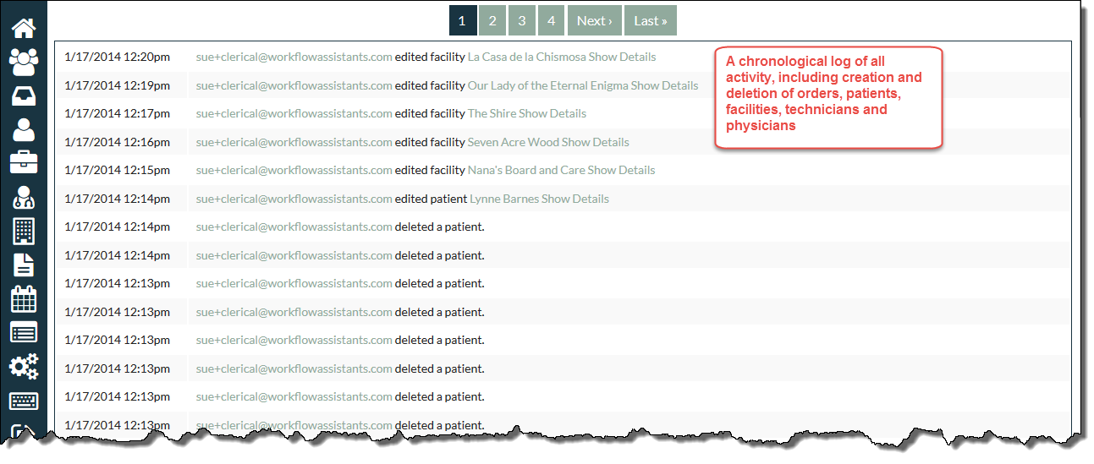

# Signing out

Click on the icon to sign out from any screen.

